

PROJECT ON USED CARS PRICE PREDICTION

Submitted by:

Sahib Hussain

**ACKNOWLEDGMENT**

This project would not have been possible without the support of many people. Many thanks to my SME, Sajid Choudhary who gave suggestion and ideas on creating this project and helped make some sense of the confusion. Also thanks to my Internship Company FlipRobo Technologies Pvt. Ltd for giving me this opportunity to work on such a project which we would be very beneficial for the Real Estate Business. For the completion of this project we took help of google to get domain knowledge about cars and what factors does people look into mostly while purchasing a second hand car. Then in order to collect the data we did scrapping of used cars from CarDekho website as it had all the information we needed to complete the project.

**INTRODUCTION**

* Business Problem Framing

With the covid 19 impact in the market, we have seen lot of changes in the car market. Now some cars are in demand hence making them costly and some are not in demand hence cheaper. One of our clients works with small traders, who sell used cars. With the change in market due to covid 19 impact, our client is facing problems with their previous car price valuation machine learning models.

* Motivation for the Problem Undertaken

This model will be used by the management to understand how exactly various factors affect the price of an used car and how much accurate result they can predict if we give all those factors as input to our model.

**Analytical Problem Framing**

* Mathematical/ Analytical Modeling of the Problem

Originally it had 1 variable as integer datatype and rest of the variables were of object datatype but we changed it into 1 varaible as float, 3 as integers and rest of them as object to create a better model.

By using Distplot from Seaborn Library available in python we found that Kms_run variable had skewness.

By using Boxplot from seaborn library we found the outliers in each of the features.

Heatmap available in Seaborn helped us to find the collinearity among various features which we will see later in this documentation.

We used countplot from seaborn to analyse the categorical features.

To make this model we used Linear Regression, Random Forest Regressor, Decision Tree Regressor, Xtreme Gradient Boost Regressor and AdaBoost Regressor.

* Data Sources and their formats

To collect data we used selenium and with the help of it we scrapped carsdekho website as it had all the important information which we needed to analyize and create this model.

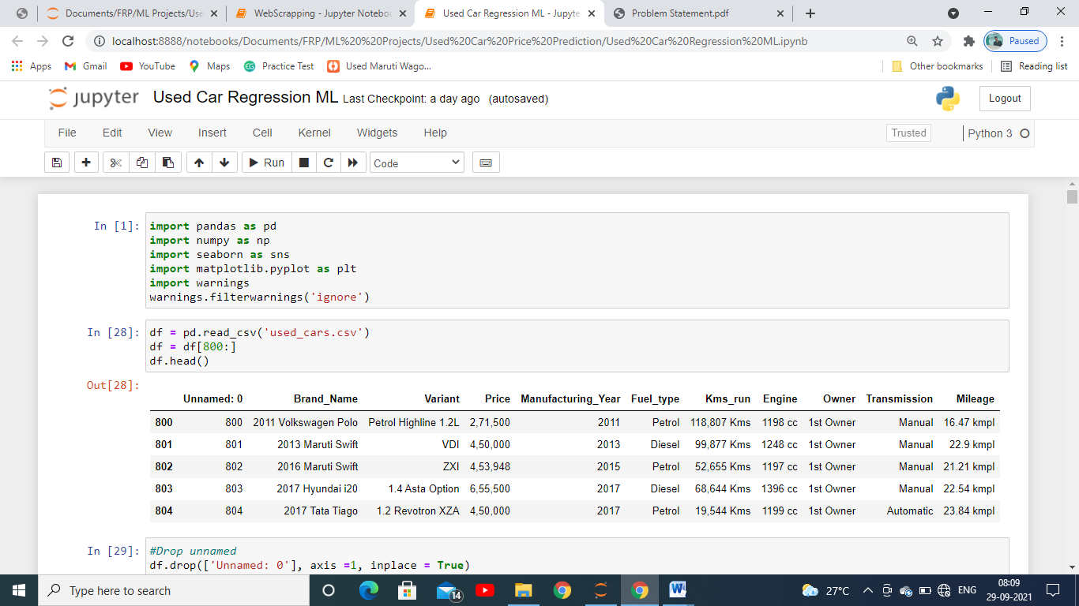

* Data Preprocessing Done

To clean the data had to delete few features as they would not had effect in getting the predictions.

Skewness were removed with the help of quantile method.

Outliers since there were too many were removed with the help of ZScore method.

* Data Inputs- Logic- Output Relationships

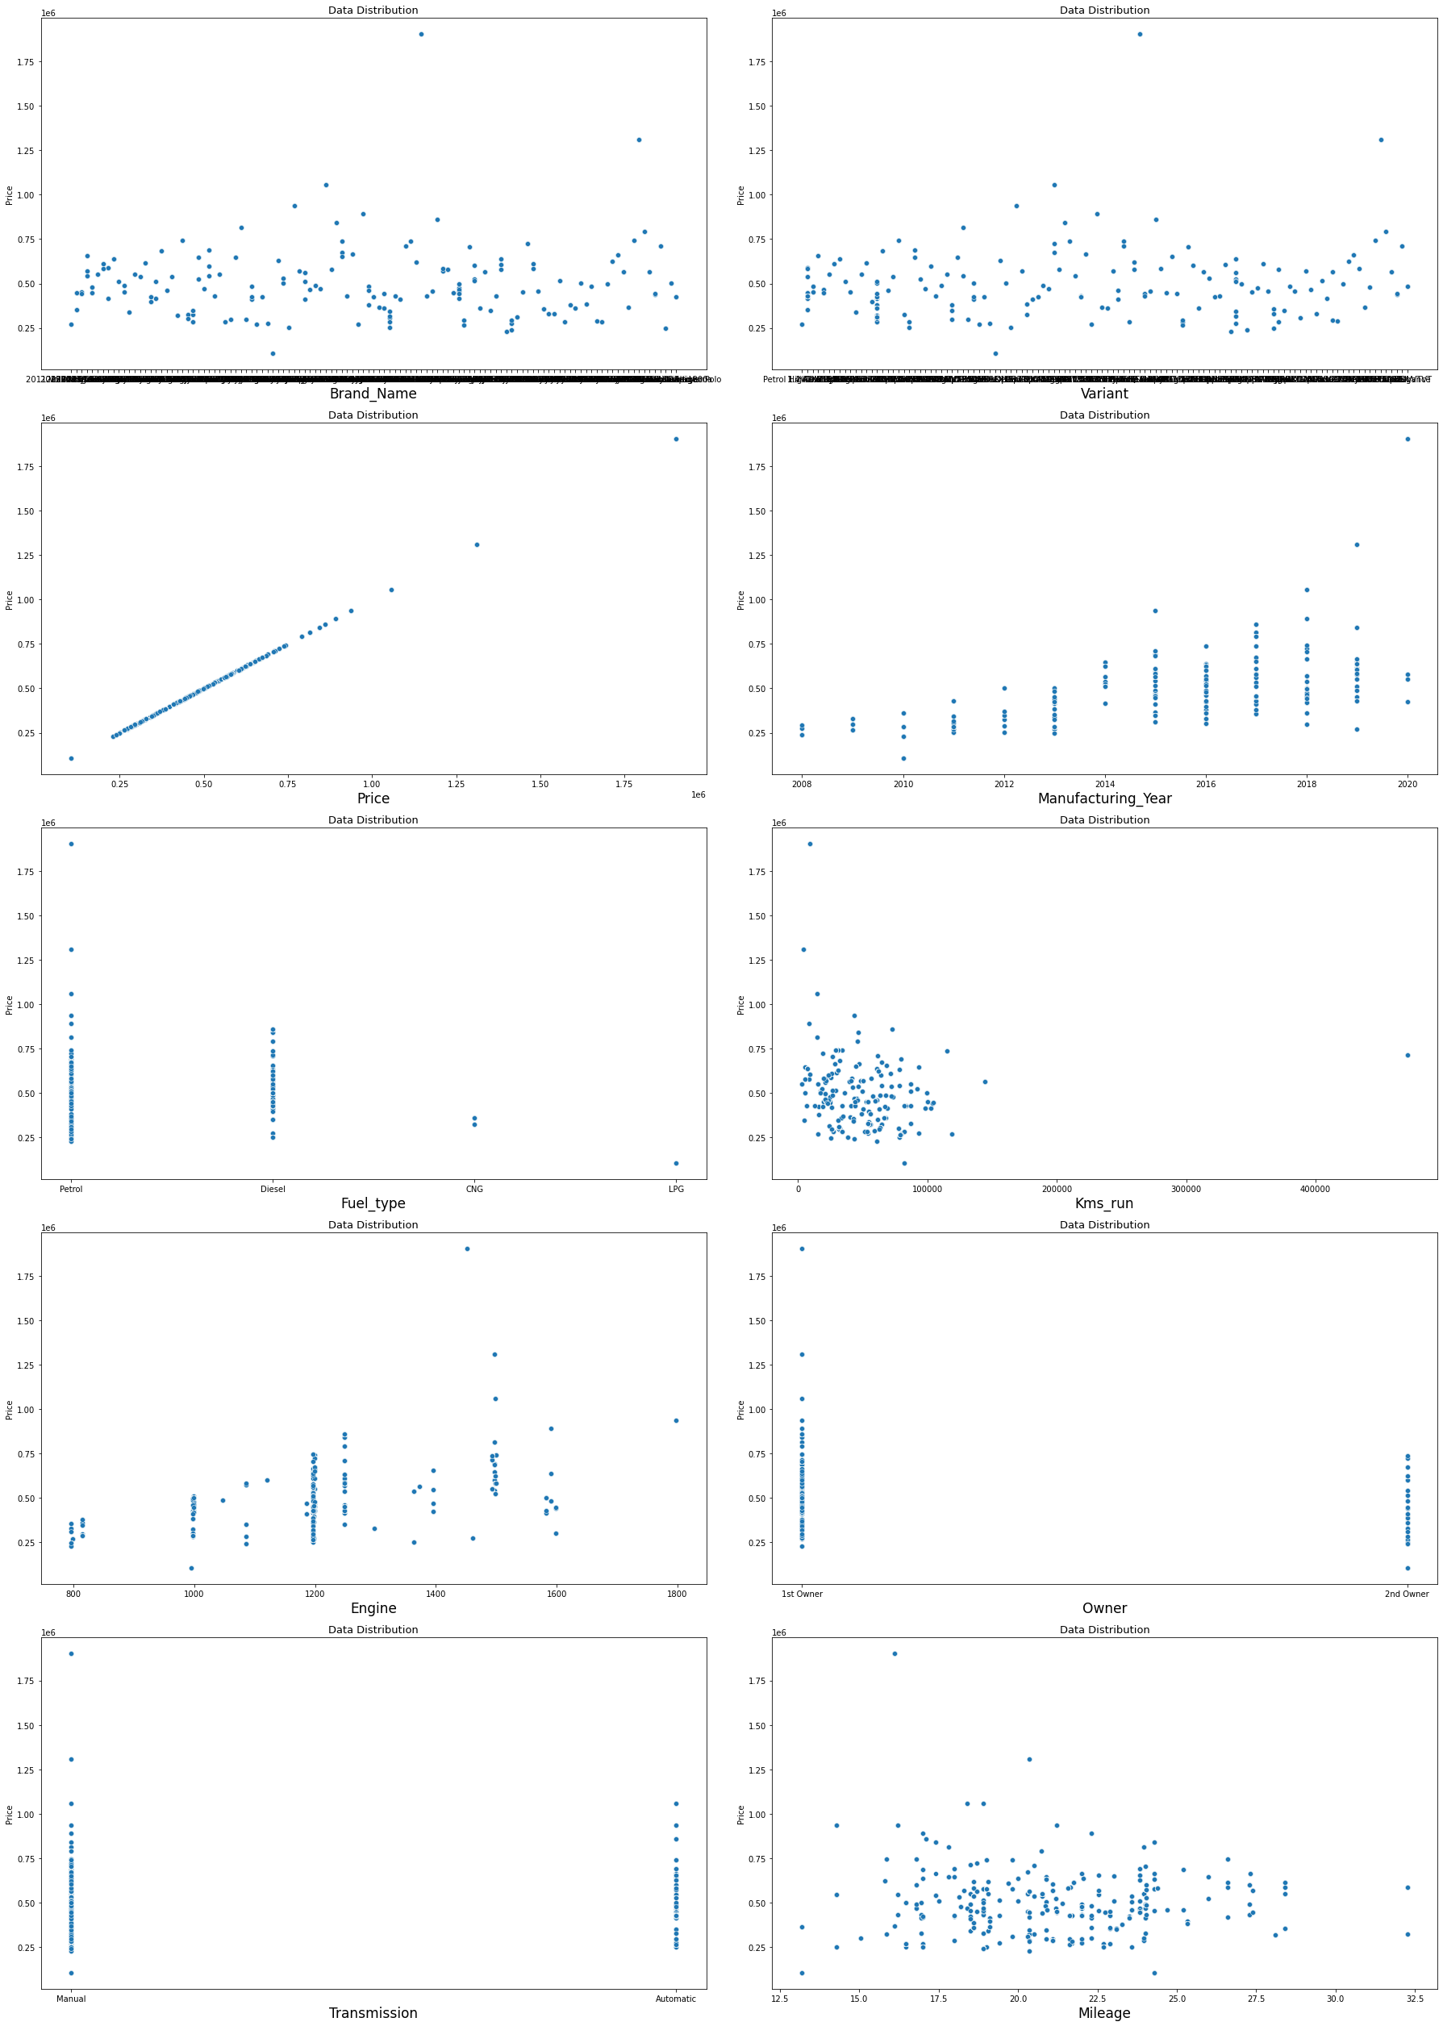

In this figure we can clearly see how variables are related with each of the features and what effects it.

For an example: Let’s take variable Kms_run

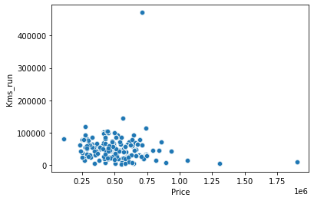

In the figure x axis contains the values of independent variable and y the value of dependent variables which in our case is Kms_run,

From the figure we can clearly see that mostly the price was higher only in case when the Kms_run by the car is less, it helped us to know how the it affects in determining the price of the car.

* Hardware and Software Requirements and Tools Used

**Software used** : In this we used Jupyter Notebook from the Anaconda to build the model, Miscrosoft powerpoint to make the powerpoint presentation and Miscrosoft word for documentation.

**Libraries used**: Pandas to read the dataset, Matplotlib and seaborn to analyse the data and Scikit Learn to build our models.

**Model/s Development and Evaluation**

* Identification of possible problem-solving approaches (methods)

As we can see that the dataset was huge there were 4848 rows and 8 columns left after removing unnecessary features and duplicate values from the dataset.

Then we checked for outliers which is abnormal data is not possible or had occurred due to some incorrect entry with the help of box plot to later on it was removed with the help of z-score.

With the help of distplot we checked for skewness, whether the data is skewed towards left or right or whether it was Normal distribution if it had normal distribution /or forms bell curve , it would have been considered good for building the model but since the data was skewed a lot and mostly towards right these had to be cleaned with the help of quantile method so that we the model doesn’t always predict the output towards which the data is skewed towards mostly.

We plotted heatmap to see if there is collinearity among the features so that repetition of the data in predicting model can be avoided. Since there was very less collinearity we didn’t had to remove any features for model building.

We scaled the data for all the independent variable which is very important in building the model

* Testing of Identified Approaches (Algorithms)

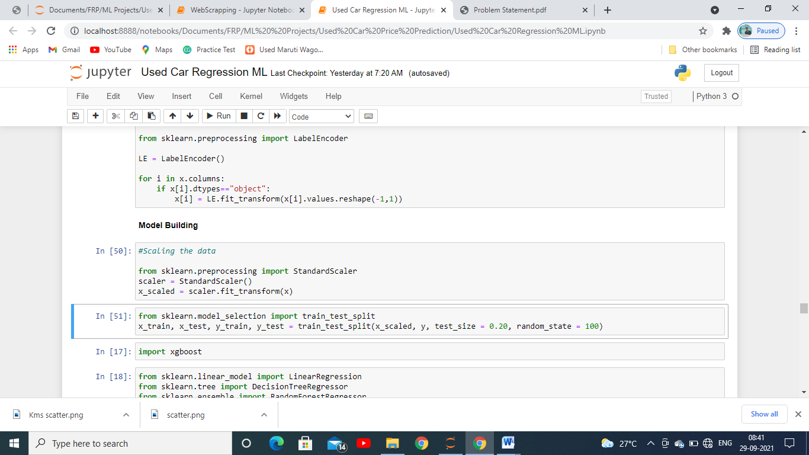

We imported the train test split as you can see in the above image.

The whole dataset after being scaled is broken down into 4 parts each for train and test, 2 parts for traning the model and 2 parts for testing, in it we kept 80% of the data for training and remaining 20% for testing the data.

* Run and Evaluate selected models

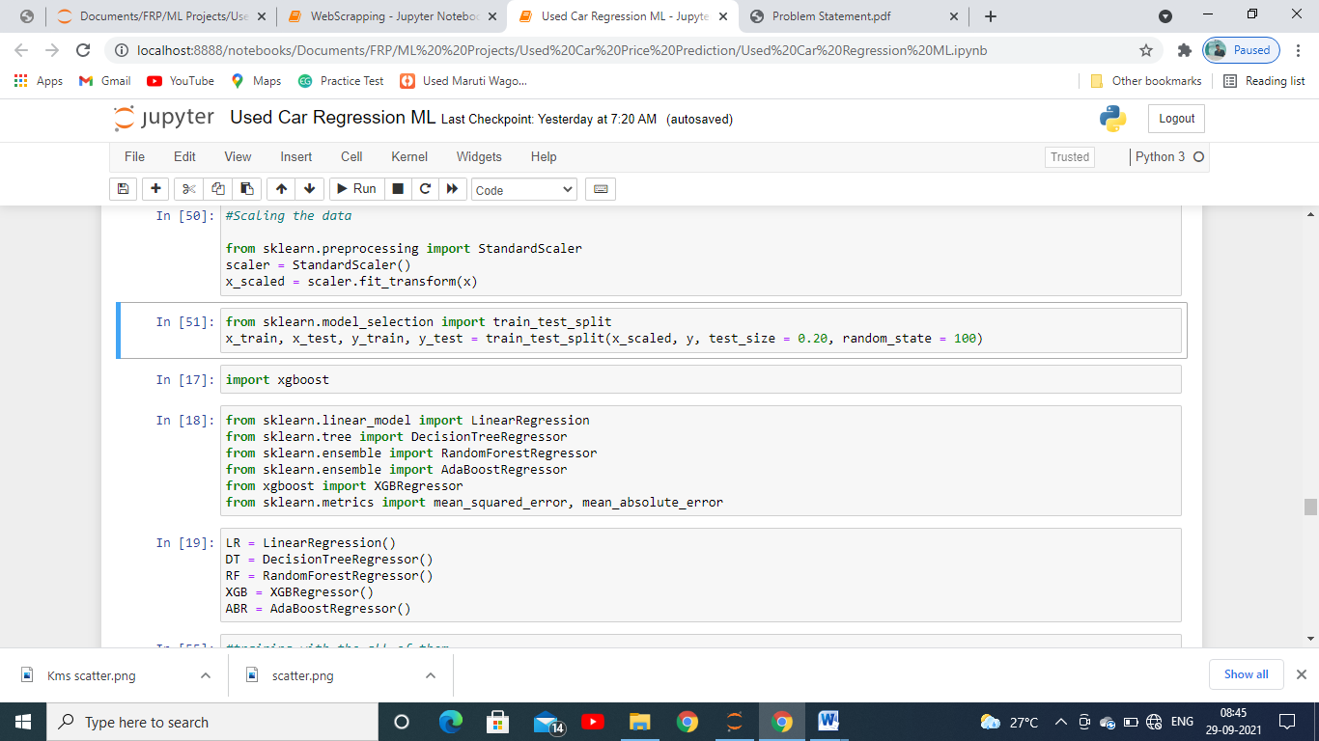

First we imported various evaluation metrics used for evaluating a regression model since the label had to be predicted is in continuous form then imported various models we are used for building classification model as you can see we imported 5 models: Linear Regression, Ada Boost Regressor, Decision Tree Regressor, RandomForest Regressor, XGBoost Regressor then we stored them in variables for each one of them which we are going to use further in building the model.

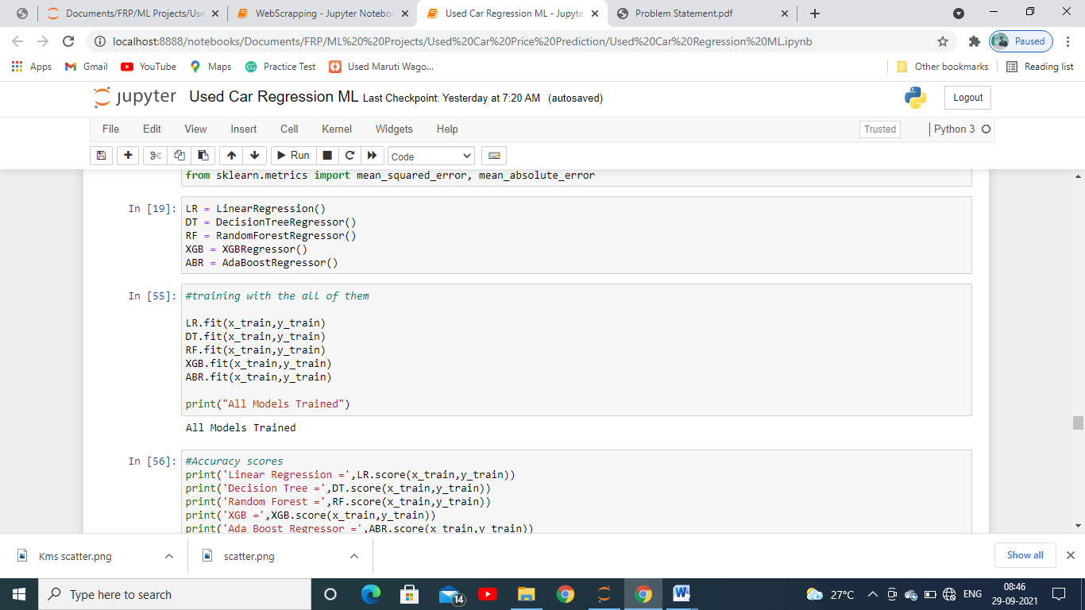

We then trained it with x_train and y_train which we got from the dataset after splitting it in train and test set. This train set composes of 80% of the data which is going to be used to study the data by the model to predict the test set.

Then we captured the accuracy and r2 score which helped us to determine performance each model is giving of each with our test set divided in 2: x_test, y_test.

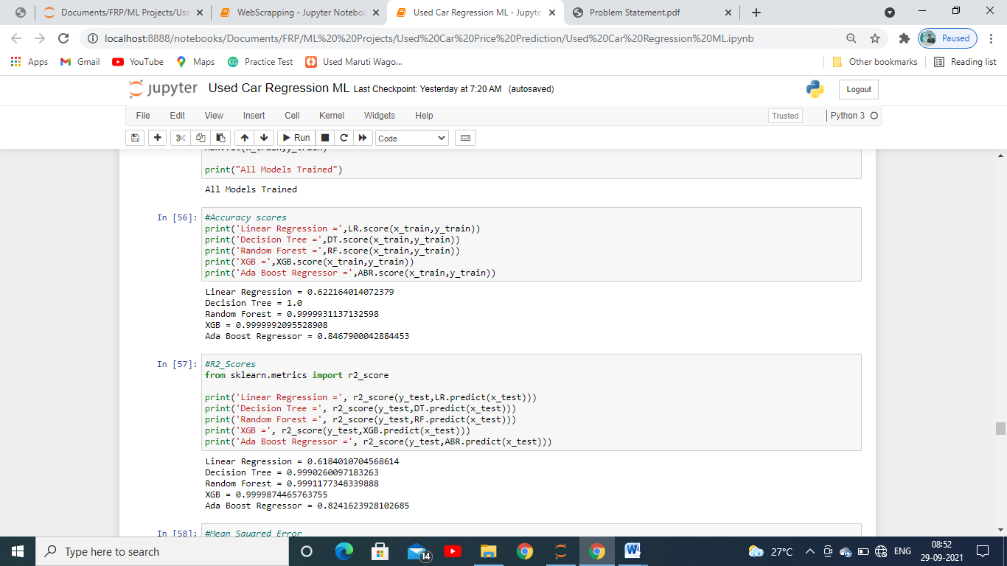

We found out score of each model which is the accuracy each model is giving for this dataset and we can see that Random Forest, Decision Tree, XGB Regressor is giving us the highest prediction with nearly about 99% approx. The least was given by Linear Regression which is of 62.21%

* Key Metrics for success in solving problem under consideration

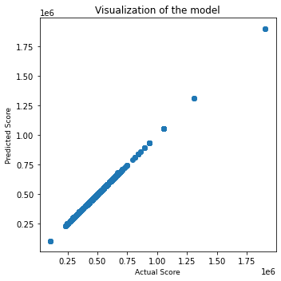

The above image is showing us the relation between our predicted values and actual values as we can see that there is not much gap for between predicted and actual datapoints for XGB Regressor which shows that the it is best fit for our dataset. Also we saw the scores of each one of them and XGB Regressor had delivered us the best scores among them when we checked all the metrics used in evaluating a model

* Visualizations

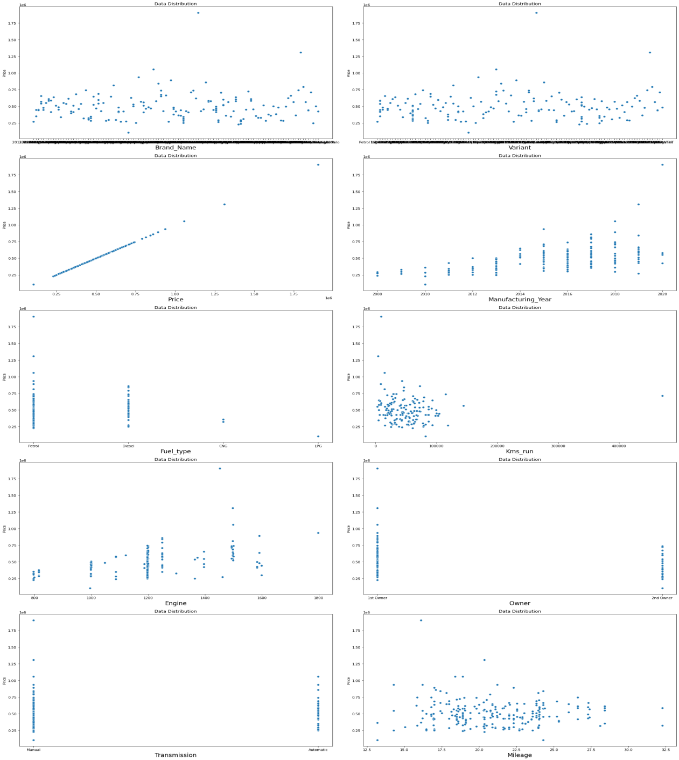

With the above image which is a scatter plot we checked how each features are affecting the label and how they are related as we saw in the beginning of this documentation.

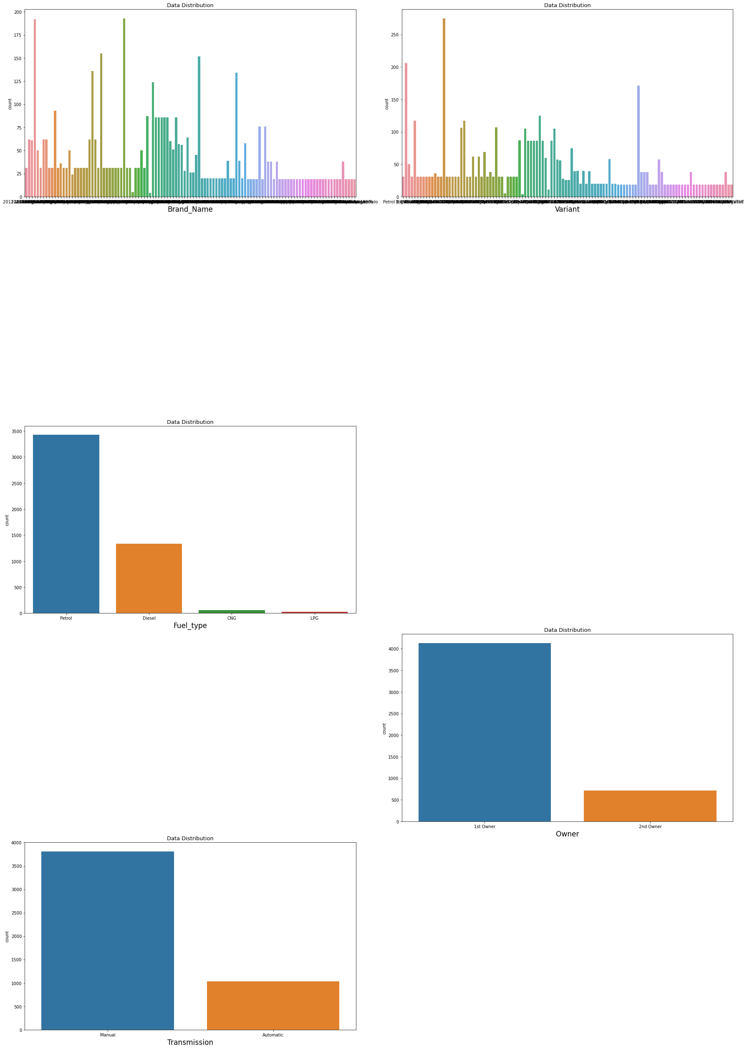

With countplot we saw the categorical columns and which category of each feature is mostly affecting the sales, Bars in blue for each feature is contributing to the sales most.

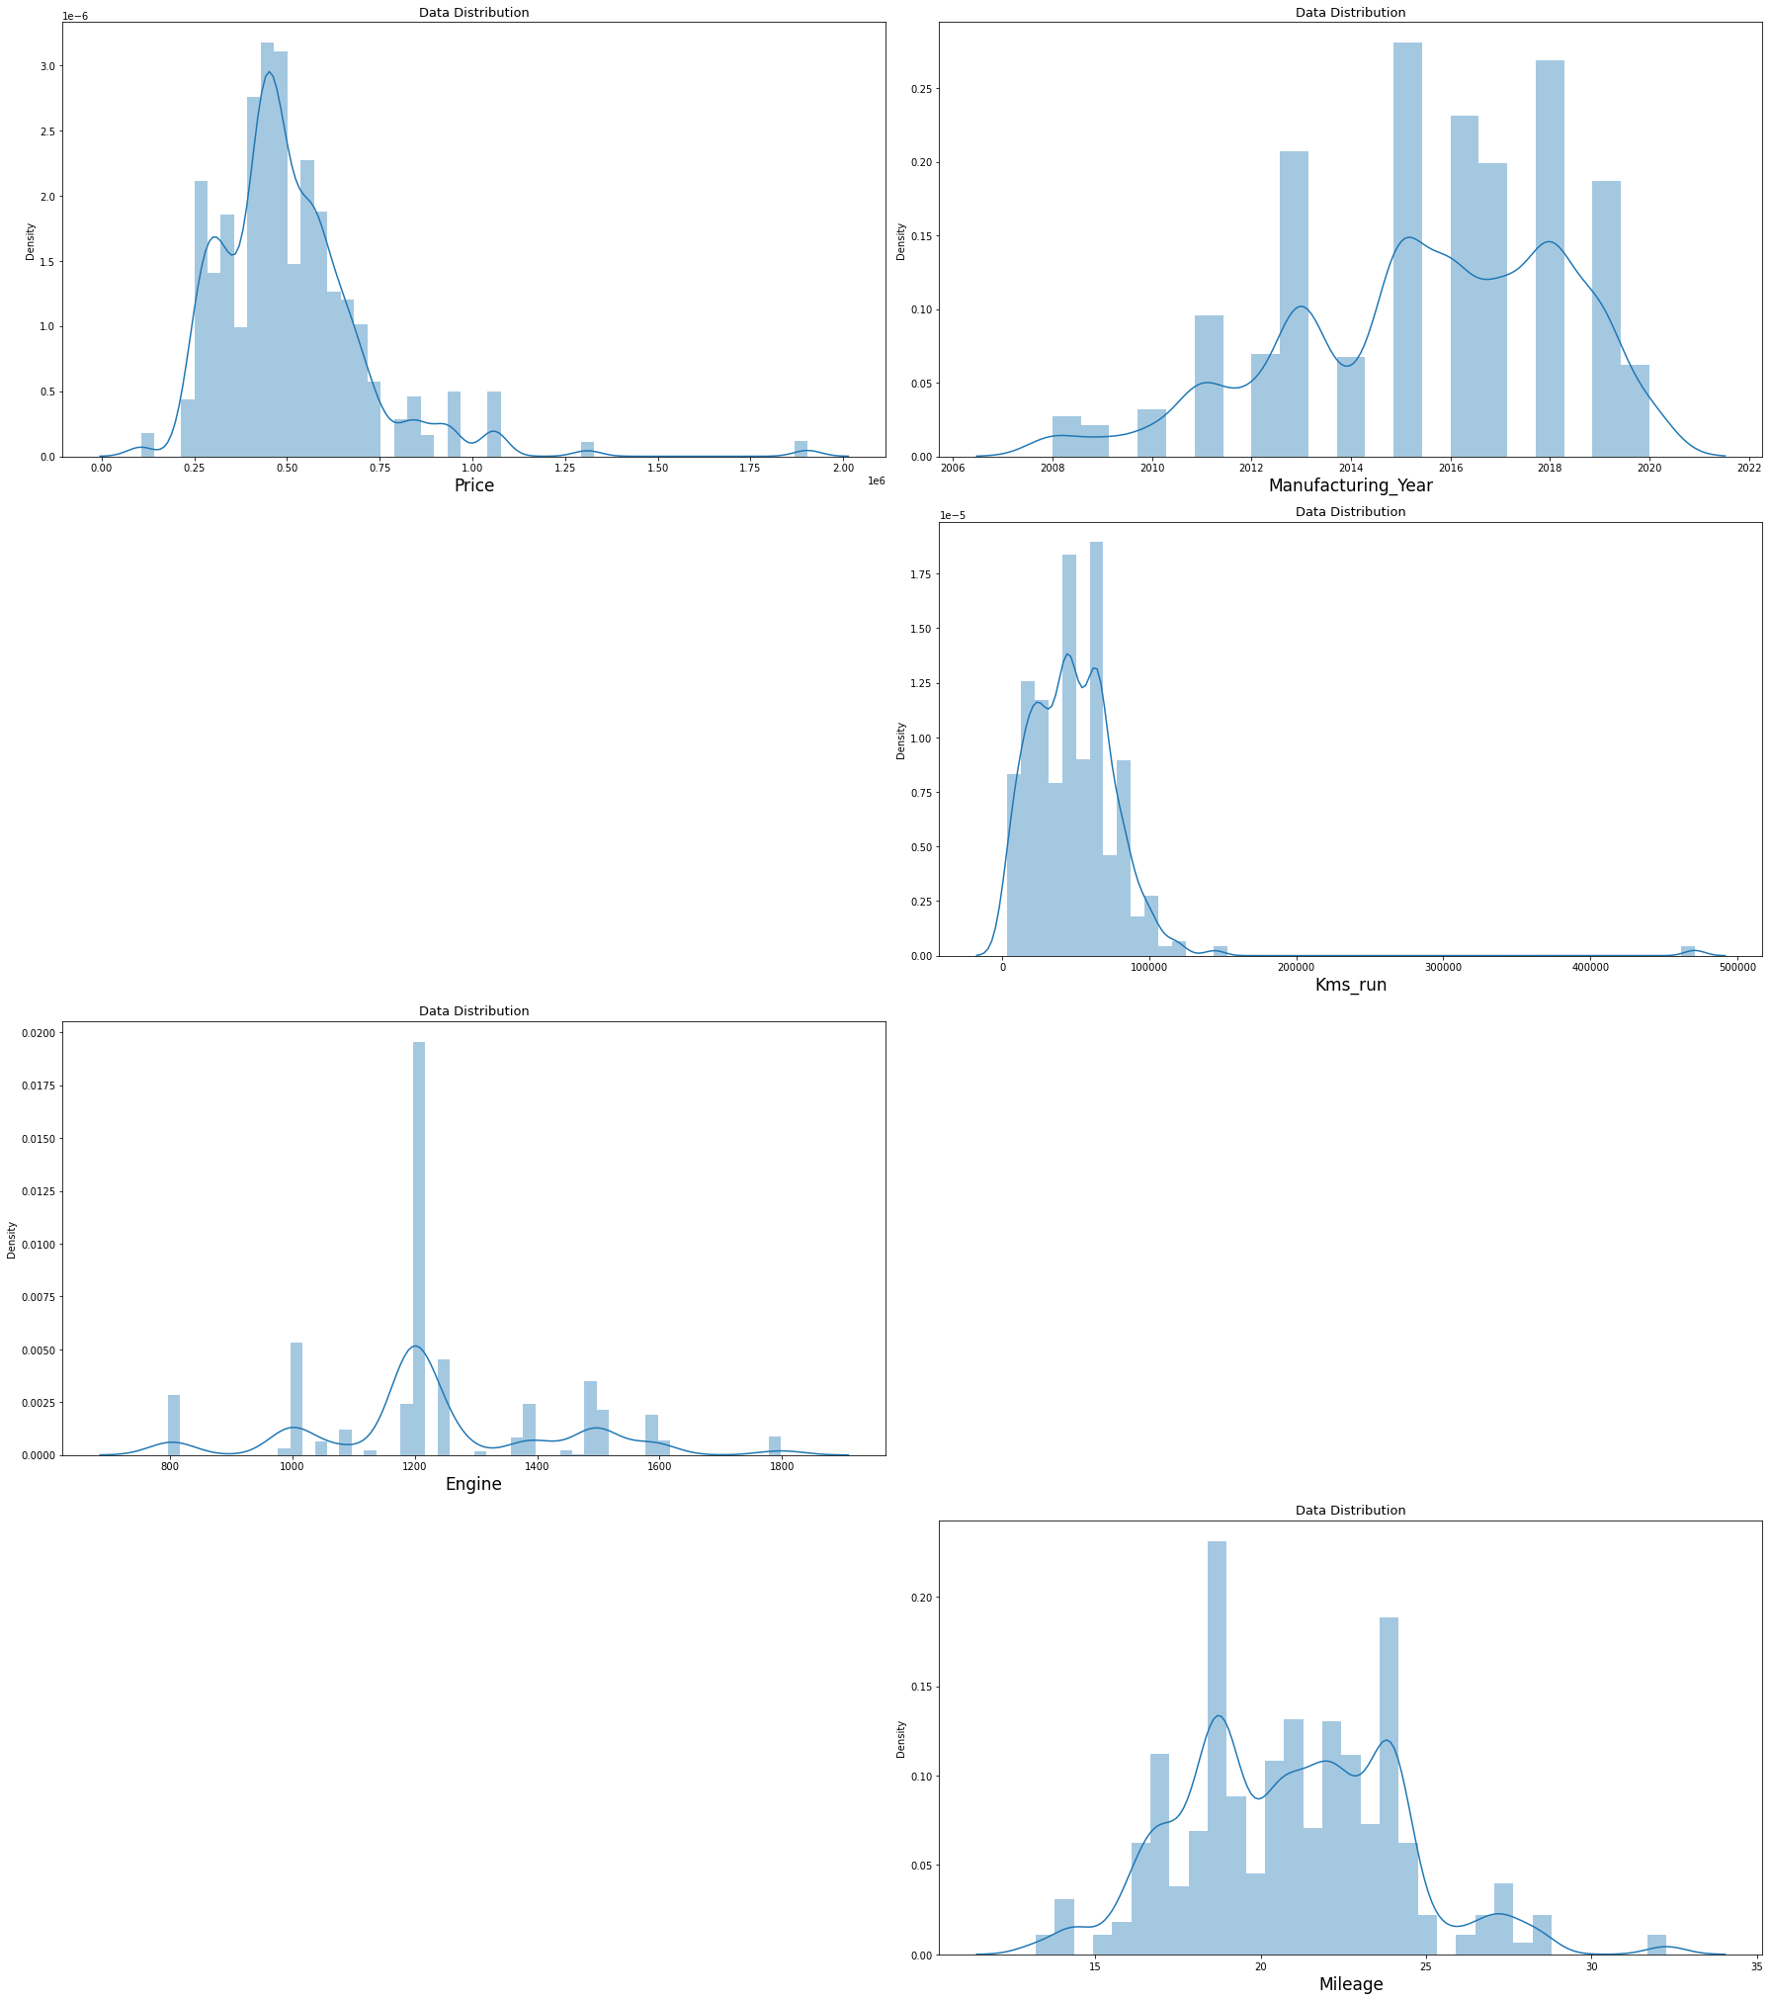

The above figure shows us the skewness for the continuous variables and we can see that only Kms_run was skewed towards right, a perfect curve would be the one which forms bell curve.

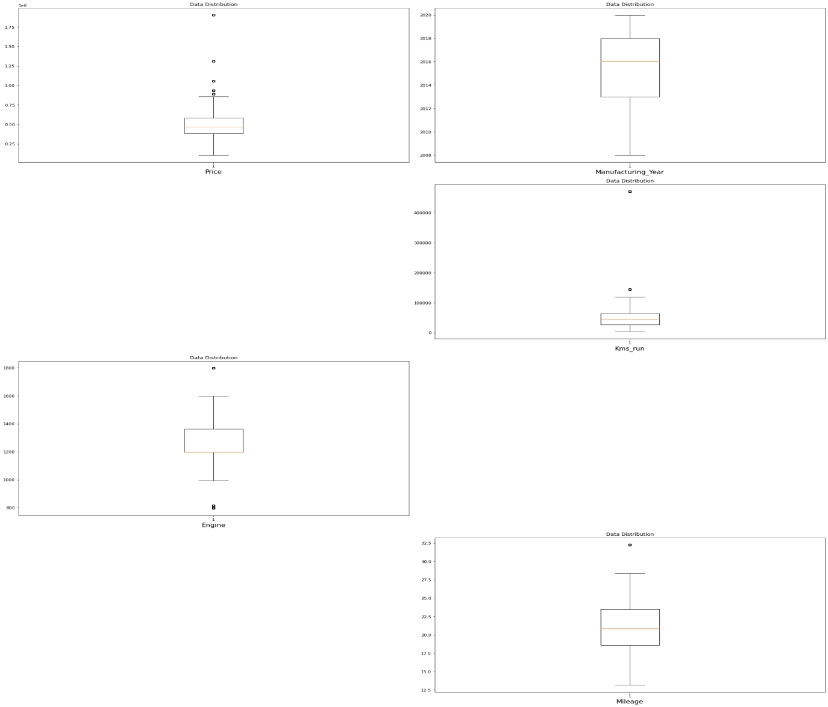

In this figure we can see the outliers in each continuous variable which is not normal or not possible in real life and it occurs mostly because of incorrect entry these had to be removed for creating a better model, it is present in Engine, Kms_run and Mileage variables of our dataset.

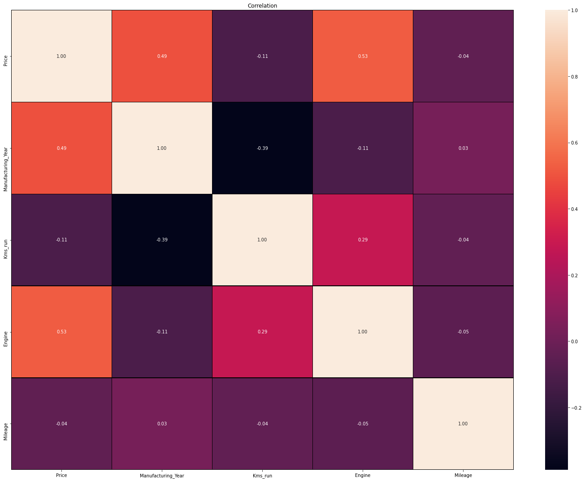

It is a heatmap which shows us the colinearity amoung features how much they are co-related near to 1 has high colinearity among them. We don’t see any multi-collinearity among the features in our dataset.

* Interpretation of the Results

After building the model we found that XGB Regressor gave us the best result taking into consideration all the metrics scores and parameters, this model had least difference between the predicted data points and actual data points.

**CONCLUSION**

* Key Findings and Conclusions of the Study

In this project we found how various factors can hugely impact the sales price of a used cars. A little bit of change in the feature of house can drastically bring change to it’s price. How important the features are in determining the price of used cars.

* Learning Outcomes of the Study in respect of Data Science

While doing this project we observed that data visualization plays a key role in analysis the data and further processing it to build a model which has very less error and more accuracy. Analysis helps us to find out which are the feature mostly affecting the label and has more weightage and on this basis the data needs to be cleaned so that the data which we get to build our model gives us the best results. Shape is used to find the number of rows and columns, info for getting what are the data types of features and whether there are any null values in it or not, if there are this needs to be either filled up or removed from the dataset so that it does not build an erroneous model for us, describe has also been used to check the quartiles and mean, standard deviation, min value and maximum value of each of the features.

* Limitations of this work and Scope for Future Work

As we saw while doing Exploratory Data Analysis that some we saw there are various models which are common and some of the models are not present in this though we didn’t considered that in building our model however if we could have got the information of those cars as well along with some more features the model could have been could not have been limited to only some these information.